Arpit Balwani

Axway

Automated provisioning of VM Images

Table of Contents

Problem statement 2

Purpose 2

Milestones 2

Phases 1 2

Phase 2 2

Participants 2

RACI 3

Progress 3

Administration 4

User Manual 6

Prerequisites. 6

Run the Script 7

Fill in the Details 8

Start the deployment 8

Check the available free space on VMWare Hosts 8

List All VM’s for an individual 8

Phase 2 9

[Secure Transport]Create a standard cluster using the Vm provisoner. 9

Introduction 9

Change Configuration ID on Secondary node 10

CFT 10

Revision History 11

Version 1.1. 11

Version 1.2. 11

Version 1.3. 11

# Problem statement

* No Ready Environment.
* Huge Latency in getting Resources.
* Existing ESX didn’t had enough space.

# Purpose

* Self Service provisioning by TSEs
* Cut down time provisioning.
* Reusability of pre-built environments
* Environment readiness.
* Resource optimization.

# Milestones

## Phases 1

* VM Template Creation through Template-Zilla for ST
  + Combination of OS and Product Version
* Automated Provisioning of VMs (app configured), using Templates.
* VM deletion module added.
* Health-check module added.

## Phase 2

* Automating architectural configurations
  + e.g. Clustering, HA, Load Balancers, shared storage, database, LDAP etc.

# Participants

* Product Specific Teams
  + ST – Arpit (E1), Akil (E2), **Chaitanya (E3)**
  + API – Mohd. Sharjil (E1), Abhinav Aggarwal (E2), Sandeep (E1), **Rahul (E3)**
  + ADI – Arpit (E1), Shivangi (E2), **Praveen (E3)**
  + B2Bi – Nitasha (E2), Jyoti (E1), **Sandeep (E3)**
  + CFT – Chirag (E1), Raju (E1), Surya (E2), Chaitanya (E2), **Abhinav (E3)**
  + MG – Surya (E1), Shivangi (E2), **Akil (E3)**

# RACI

|  |  |  |  |  |
| --- | --- | --- | --- | --- |
| Particulars | R | A | C | I |
| OS & Product Creation | E2 | E3 | E1, E3, PM | PM |
| Template Creation | E1 | E3 | E2, E3, PM | PM |
| Topology Creation | E1, E2 | E3 | PM | PM |

# Progress

Secure Transport

|  |  |  |  |
| --- | --- | --- | --- |
| Environment | OS & Product Creation | Template Creation | Topology Creation |
| SUSE 12.1 ST 5.3.3 | Y | Y | Y |
| SUSE 12.1 ST 5.3.6 | Y | Y | Y |
| SUSE 12.1 ST 5.4.0 | Y | Y | Y |
| RHEL 7.6 ST 5.3.3 | Y | Y | Y |
| RHEL 7.6 ST 5.3.6 | Y | Y | Y |
| RHEL 7.6 ST 5.4.0 | Y | Y | Y |
| Windows 2008 ST | Y | Y | Y |
| Windows 2008 ST | Y | Y | Y |
| Windows 2008 ST | Y | Y | Y |
| Windows 2012 ST | Y | Y | Y |
| Windows 2012 ST | Y | Y | Y |
| Windows 2012 ST | Y | Y | Y |

CFT

|  |  |  |  |
| --- | --- | --- | --- |
| Environment | OS & Product Creation | Template Creation | Topology Creation |
| SUSE 11 SP4 CFT324 | Y | Y | Y |
| SUSE11SP4_CFT332 | Y | Y | Y |
| SUSE11SP4 CFT340 | Y | Y | Y |
| RHEL72 CFT324 | Y | y | y |
| RHEL72 CFT332 | y | y | y |
| RHEL71 CFT340 | y | y | y |
| Win2k8_CFT324 | Y | Y | Y |
| Win2k12_CFT332 | Y | Y | Y |
| Win2k12_CFT340 | Y | Y | Y |

API

|  |  |  |  |
| --- | --- | --- | --- |
| Environment | OS & Product Creation | Template Creation | Topology Creation |
| RHEL7_APIALL | y | y | Y |

CG

|  |  |  |  |
| --- | --- | --- | --- |
| Environment | OS & Product Creation | Template Creation | Topology Creation |
| CG113_CentOs7 | Y | Y | Y |

B2BI

|  |  |  |  |
| --- | --- | --- | --- |
| Environment | OS & Product Creation | Template Creation | Topology Creation |
| RHEL7_B2BI231 | Y | Y | Y |
| RHEL7_B2BI240 | Y | Y | Y |

# Administration

There are two groups with the following roles:

1. **Normal User** , roles include create/delete/startVM/stopVm
2. **Administrator User** , roles include all of the normal user’s along with :
   1. Template creation /deletion
   2. Snapshot creation , revert deletion

|  |  |  |
| --- | --- | --- |
| TSE | Administration Rights | Normal Rights |
| Arpit | ✓ | ✓ |
| Akil | ✓ | ✓ |
| Chaitanya | ✓ | ✓ |
| Tapan | **✕** | ✓ |
| Surya | **✕** | ✓ |
| Nitasha | **✕** | ✓ |
| Abhinav | **✕** | ✓ |
| Sharjil | **✕** | ✓ |
| Praveen | ✓ | ✓ |
| Chirag | **✕** | ✓ |
| Sandeep | **✕** | ✓ |
| Raju | **✕** | ✓ |
| Rahul | ✓ | ✓ |
| Shivangi | **✕** | ✓ |
| Nidhi | **✕** | ✓ |
| Jyoti | **✕** | ✓ |
| Mohit | **✕** | ✓ |
| Vatsalya | **✕** | ✓ |
| Aarti | **✕** | ✓ |

# User Manual

## Prerequisites.

* .NET Framework 4.5 or newer.

https://www.microsoft.com/en-us/download/details.aspx?id=30653

* PowerShell 5.0 or newer.

https://www.microsoft.com/en-us/download/details.aspx?id=50395

* Change PowerShell Execution Policy:

#### Open PowerShell as **Administrator** and run “**Set-ExecutionPolicy RemoteSigned**” and confirm the change with “**Y**”.

## Run the Script

* Open **PowerShell** as a regular user, **cd** to the folder where the script is and Run “**.\TemplateZillaRun101.ps1**” to get the GUI for automatic VM deployment.

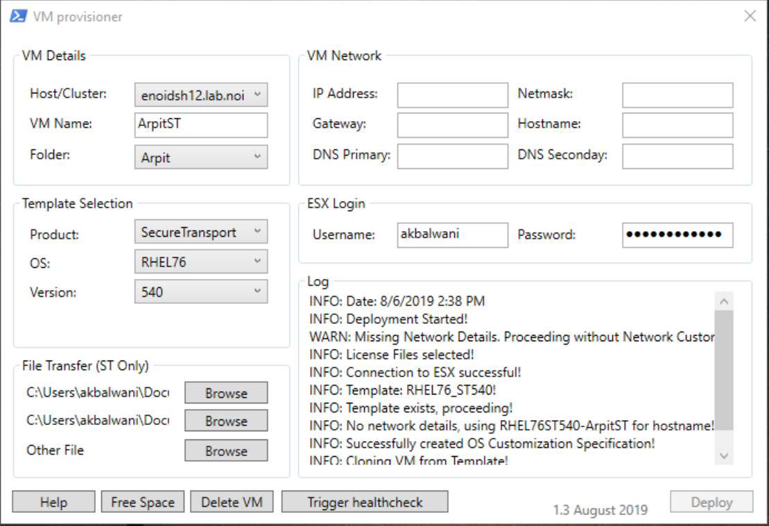

## Fill in the Details

* Select the ESX Hots/Cluster, where you Aim to deploy this new VM.
* Fil the new VM Name as per the support VM name convention.

E.g. ArpitST”.

* Select the Folder where the new VM should be placed. Each support engineer has a separate folder.
* Select the Product name, OS and Version for which the VM would be deployed.
* Linux VMs for ST have both Edge and Core installed. Windows Server only allows single ST instance, so a separate template is used for deployment.
* Enter the Username and Password required to login to the ESX Server.
* If the product is “SecureTransport”, optionally enter Network details. For “MailGate” the Network details are required.(NEED STATIC IP FIRST)
* Enter Network details - IP / Gateway / Netmask / Hostname* / Primary DNS and optionally Secondary DNS. Common addresses are already filled up, but can be changed if necessary.
* For “MailGate” the same hostname and network configuration must be used latter in the MG installation wizard.

* Hostname can either be short, e.g. “testvm” or FQDN.

* If the product is “SecureTransport”, optionally select files under File Transfer to be sent to the new VM.
* Click the “Browse” button next Core License, Features License and Other File to select the appropriate file to upload to the server. License files would be transferred to the configuration folders of all ST installations. The Other file would be copied to:
* C:\Axway on Windows Server
* /root/ on Linux and Appliance

## Start the deployment

* Click the Deploy button and wait. Check the Log for the status of the deployment.
* Start using the new server

## Check the available free space on VMWare Hosts

* Fill in the ESX Login Details.
* Click “Free Space” button.

## List All VM’s for an individual

* Fill the login details.
* Select the engineer name from Folder drop down.
* Hit List All button.

# Phase 2

We will try to deploy application level cluster for different Application for the following projects:

1. [Secure Transport]Create a standard cluster using the Vm provisoner
2. [CFT]Create a cluster Enviroment using the Vm provisoner

## [Secure Transport]Create a standard cluster using the Vm provisoner.

### Introduction

All Backend servers are installed with the same “secret” file.

All Edge server are also installed with a matching “secret” file, however it differs from the one used on backend.

The problem comes from the VMs being deployed from the same template and having the same Configuration ID, thus to cluster 2 or more VMs their IDs must be changed.

### Change Configuration ID on Secondary node

1. Start the database
2. Navigate to “$FILEDRIVEHOME/conf” and edit “configuration.xml”; then find “LocalConfigurationsId”
3. Copy the string somewhere, then change a few characters (but preserve the length), copy the new string, as well. Save the file
4. Dump the database by going to “$FILEDRIVEHOME/mysql/bin” and executing:
5. ./mysqldump --defaults-file=../../conf/mysql.conf --databases st -ptumbleweed > /tmp/st_full_db.sql
6. Run:

sed -i 's/oldLocalConfigurationsId/newLocalConfigurationsId/g' /tmp/st_full_db.sql

Example:

sed -i 's/a3104704b74a9e673859e138b49fa87d/b3850424bsae19109984a87seg73549o/g' /tmp/st_full_db.sql

1. Import the edited mysql dump

./mysql --defaults-file=../../conf/mysql.conf -ptumbleweed st < /tmp/st_full_db.sql

8. Proceed with normal cluster configuration:

a. Configure “cluster.mode” parameter

b. Configure “servers” file

c. On passive_legacy and Edge server, create the “sentinel_primary” file on Primary node

## CFT

|  |  |  |
| --- | --- | --- |
| Step | TSE assigned | Percentage |
| Script to Mount NFS share | Chaitanya seth | 100% |
| Topology check | Abhinav /Chirag /Chaitanya |  |

# Revision History

## Version 1.1.

The phase one ready products, secure transport with version 5.4.0, 5.3.6 & CFT 3.3.2 , 3.2.4 and 3.4.0 on versions on multiple operating systems.

## Version 1.2.

1. Phase two ready for ST with the 5.4.0 and 5.3.6 versions
2. Phase one ready B2BI
3. Newly added features to list out VMs for specific person and to delete it right from the tool.

## Version 1.3.

1. Phase 1, API closes with 3 templates on version 7.5.3 , 7.6.2 and 7.7.0.
2. B2BI templates issue raised was fixed.